CMIT 202 6385
PC Build and Manual Part II
September 23, 2018

Introduction: When building a computer there are many routes that can be taken depending on the users’ needs. Approximate date I need the computer? What is it going to be used for? How much will it cost? These questions will determine whether or not it is feasible for you to build your own PC or to purchase one from a store fully built.
This lesson will cover the ends and outs of building a PC for a more general and overall personal PC.
***** Remember while handling NON-power supply components, monitors, and high voltage components ensure you have grounding through an Electro-static Wrist strap to your non-dominate hand and clipped to the PC’s frame. *****
Tools required for installation of parts for PART II:
- (1) Anti-static Mat
- (1) Anti-static Wrist Strap with ground clip
- (1) Screwdriver, w/ multiple attachments
Parts required minimally for PART II:
- (1) Monitor
- (1) Keyboard (USB)
- (1) Mouse (USB)
- (1) High Definition Multimedia Interface (HDMI) Cable
- (2) Serial Advanced Technology Attachment (SATA) Cables
- (1) Internal SATA Hard Drive
- (1) Internal SATA CD/DVD drive.
- (1) Crossfire video adapter, Peripheral Component Interconnect-Express (PCI-E) 16x

Part 6 of 12: Installation of Hard Disk
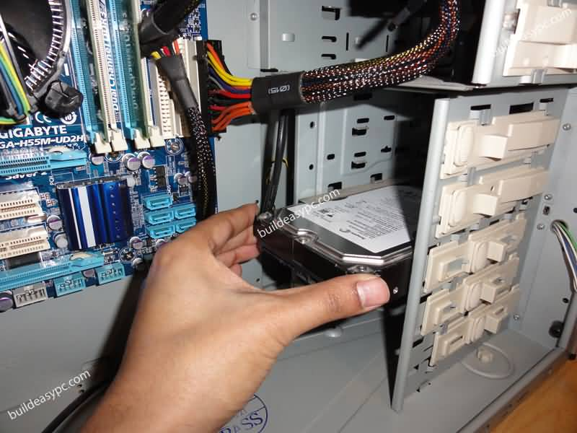
It can be vastly different when building computers due to the numerous amounts of parts. When choosing a Hard Drive, you want to consider the storage size you might need and the amount of drives that your computer is able to utilize.

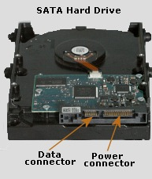
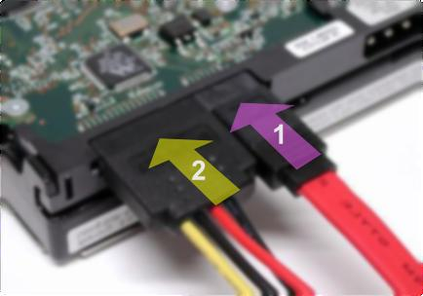
- First, we need to identify the open slots at the rear of the computer case. Once we have located the installation slot, with an anti-static wrist strap on, remove the Hard Disk from the bag and place it onto the computer drive bay with the power and SATA port facing inward/inside the casing. Once it is positioned correctly ensure you screw 4 screws on each side of the drive bay to secure it.
SATA Hard Drive ports
- R-Data Cable
- 15-pin SATA Power Cable

- Once the Hard Drive has been secured, we will need to attach a SATA Data Cable, as well as the 15-pin Power Cable to the back of the drive.
- Once the power and data cables have been installed we will want to identify the SATA port on the motherboard to attach the Hard Drive to the motherboard. Below is a photo depicting what SATA ports look like on the motherboard.
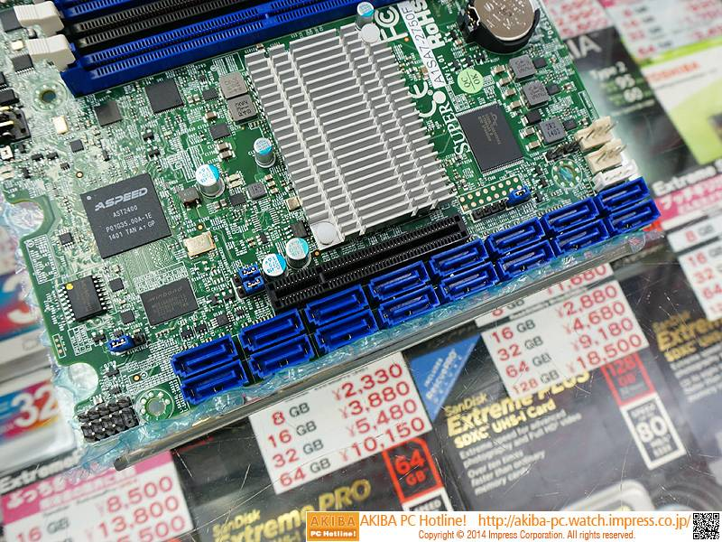

Part 7 of 12: Installation of the Optical Drive
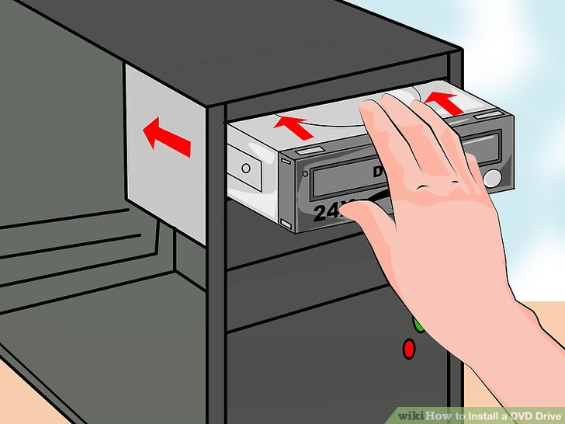
Optical Drives are used to store large amounts of data on a portable device such as a CD, DVD, or BD. Today, we will be installing a CD/DVD drive by attaching the power and data ports to the drive as we did on the Hard Drive.
- Identify the available drive by on the computer case and with an anti-static wrist strap on, remove the Optical Drive from the bag and place it into the computer casing with the power and SATA port facing inward towards the inside of the casing. Fasten the drive down with 4 screws.
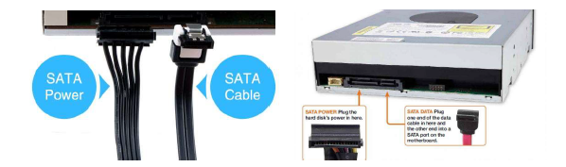
- Once the Optical Drive has been installed we will then attach the SATA Data and Power cables.
Left; SATA Power Cable.
Right; SATA Data Cable
Left; SATA Power Cable.
Right; SATA Data Cable
Optical Drive Location on a Tower

- Once the power and data cables have been installed we will want to identify the SATA port on the motherboard to attach the Optical Drive to the motherboard. Below is a photo depicting what SATA ports look like on the motherboard.

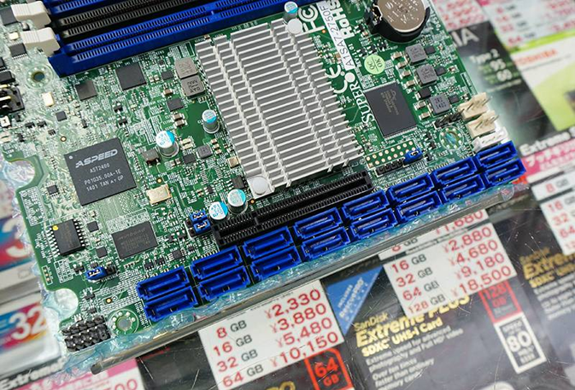

Part 8 of 12: Installation of the Video Card
The video card of choice is the Crossfire PCI-E 16x Video Card, which is enough to handle normal video output operations. This video card will utilize the PCI-E expansion slot on the motherboard which will be described how to install below.
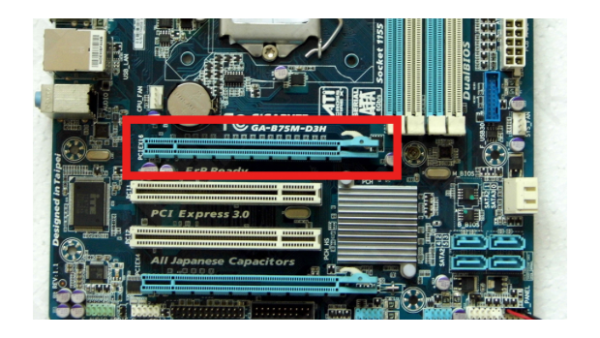
- First things first, identify the PCI-E x16 expansion slot on the mother board. Below is a photo depicting what slot this typically is on a motherboard.
PCI-E 16x slot
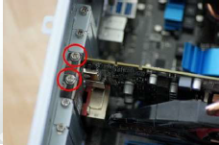
- Once identifying where the PCI-E x16 slot carefully insert it and make sure it is seated properly in its slot. Once it is firmly inserted screw it into the casing to ensure it is secured.

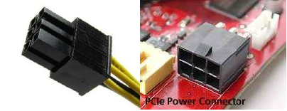
- After installing the video card, identify the 6-pin PCI-E cable for the power and connect it to the video adapter.

Once the video card has been installed this is the final portion of internal PC components. It is critical you physically check the parts to ensure it was properly installed. Additionally, this is where you would secure all the wires and make sure everything is organized within the computer itself.
Once complete, attach the panel to the side and secure it by using either screws or snapping into place.

Part 9 of 12: Monitor, Keyboard and Mouse Installation
These parts of a computer are considered to be known as peripherals and serve as the navigation portion for the user to drive the computer to do as the user wishes. Peripherals are also known as input and output devices.
- First, remove each of these components from the package and place them in your working station.
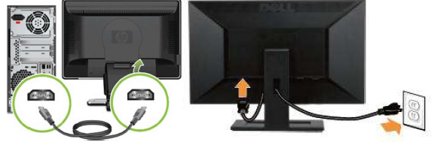
- Next, we will be installing an HDMI cable from the monitor to the PC. This is for the PC to reflect its data back to the monitor for the user to see what is happening on the computer. The monitor is known as an output device because it outputs the data from the computer. Below is a photo identifying HDMI slots and the process of connecting a monitor.

- Take the HDMI cord and plug one end to the HDMI port on the back of the monitor, then take the other end of the HDMI and plug it in to the back of the PC as shown on the left photo above
- Next, take the AC power cabling and plug the female end into the back of the monitor and the male end into the wall outlet.
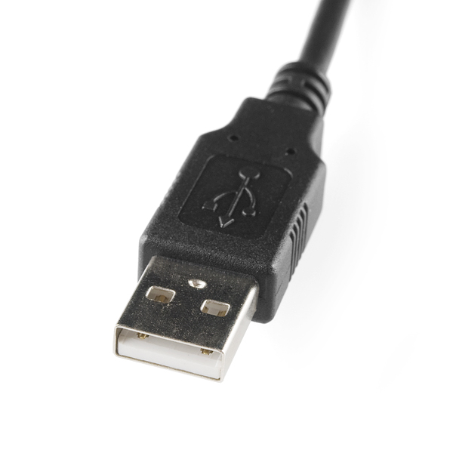

- Once the monitor is all set up we will hen install the keyboard and mouse. These peripherals are known as input devices. These devices typically utilize the USB ports, today, we will be utilizing keyboard and mouse with USB. Each device has its own USB, ensure you plug both of these in to the back end of the computer for usage of these parts. NOTE: there are no power cables for these devices.
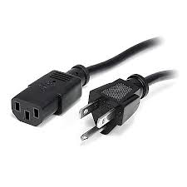
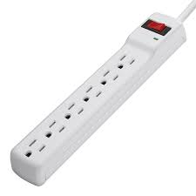
- Once the keyboard and mouse have been installed we will now connect the computer to the outlet for power. It is HIGHLY recommended that you use a Surge Protector when connecting a computer to power. This protects your system from power surges that happen annually.

Power cable

Surge Protector

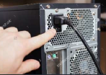
- Take the surge protector and plug the male in into the wall outlet. Once you have one this you are ready to connect the power cable. Take the female end and plug it into the back of the computer as shown to the right. Then you will take the male end and plug it into the surge protector as if it was the wall socket.
NOTE: prior to turning on the system ensure the computer voltage switch is set to 115v. This will depend highly on he computer system you are utilizing. However, for this setup we will be using 115v
- Now that everything is plugged in and all set within the computer system we can now turn everything on. First press the power button on the monitor AND computer.
Part 10 of 12: Configuration of the BIOS
BIOS or Basic Input Output System is software that ensures that the components within the system are in fully working condition. This test of all known components is called POST, which will identify any errors with the system.
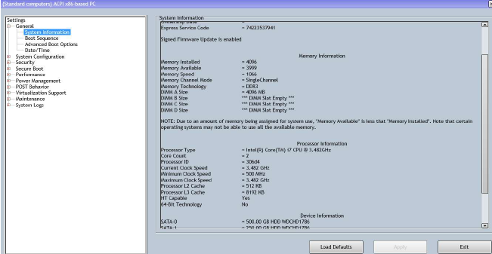
Typical BIOS

- To Access the BIOS you will have to insert a certain key on the keyboard while it is botting up. Typically, it is the F2 key. However, this can vary from manufacturers. Once we have identified which key and press it while booting we will see a screen similar to the one above.

- In the System Management tab, you will see the following information:

  - Memory Installed
  - DIMM: the size of the RAM
  - Processor Type: Type of CPU installed
  - SATA 0/1/2: Which SATA port is turned on with a hard drive installed

- In the BIOS there are other categories
  - System configuration
    - Integrated NIC: Enable/Disable NIC connection
    - Drives: Enable/Disable SATA connections
    - USB: Enable/Disable the use of USB ports
  - Security
    - System Password: password for booting the computer
    - Admin Password: password in order to alter the BIOS

- Once you have verified all of the settings in your BIOS the next thing to prioritize is the boot sequence/order. This tells the computer which item to boot from in order. We will be setting the boot sequence to initially boot from the optical drive which requires us to set it to CD/DVD/CD-RW Drive setting.

Once you have made this adjustment you will have to confirm it at the bottom of the BIOS by clicking “Apply” and then “Exit”

This completes Part II of the PC manual.

References:
- TestOut PC Pro. TestOut (Online). Derived from: Http://ww.testout.com

